Annual Project Progress Report

Project title: | Towards decent work for people with disabilities in Turkmenistan: transforming social enterprises into meaningful training and employment opportunities
Award ID: | 00097775
Project ID: | 00101359
Implementing partner(s): | Blind and Deaf Society of Turkmenistan
Period covered in this report: | 1 January – 31 December 2023
Date of last Annual Report: | 28.12.2022
Date of the last Project Board meeting: | 14.02.2022
Date of last Quality Assurance and rating: | 12.20.2023 ASM-02787 | Procedure | Salesforce

- Project Performance
Please state the expected Output of the Project, set indicators and corresponding
CP Outcome (as per project document/AWP):
In 2023, Output 2 and 3 had budget for implementation of activities. Although activities of the Output 1 were completed in previous years, its targets could only be reached in 2023 upon completion of activities under Output 2 and 3. Therefore, the below report is provided for Output 1.

Project Output 1:
Capacity of the BDST to help its members gain access to quality vocational training and decent work increased.

Output indicators:
1.1 The number of employed BDST members by gender - 490
1.2 The number of trained BDST members by gender - 180
1.3 Growth of income among target BDST members - 10%

Output targets:
1.1. Developing and presenting capacity building plans and business strategies for marketing activities for the three selected enterprises
1.2. Training on employment of people with disabilities
a) Were the indicators and output achieved? Yes No Partially
b) If no or partially, please explain why?

Some targets under this output were achieved in 2021 and 2022 and output indicators could only be achieved in 2023 following the completion of modernization of the BDST Training and Production Enterprises in the cities of Ashgabat, Mary and Turkmenabat under Output 2 by renovating and re-equipping 3 social enterprises of the BDST and training staff to operate new equipment under Output 3. Opportunities for new jobs were created, making it possible to increase the number of employed BDST members by gender. As of November 30, 2023, the number of employed by BDST is 582, of which 320 women and 262 men. The number of employed persons with disabilities is 415, of which 225 women and 190 men. BDST plans to increase the number of employed persons with disabilities by 490 in the coming year. As per the report from BDST, the growth of income among target BDST members is 40%. The number of trained by gender by the end of project reached 180 people, of which 67 are women.

Project Output 2:

Three selected Training and Production Enterprises (TPEs) of the BDST modernized and reequipped

Output indicators:

2.1 Number of enterprises refurbished and re-equipped with new modern equipment that meet the needs of people with disabilities – 3
2.2 Number of new jobs created for people with disabilities – 44

Output targets:

2.3 Carrying out major repairs of production areas in selected workshops of the BDST
2.4-2.5 Procurement, installation of printing equipment at the BDST TPE in Ashgabat and sewing equipment at the two TPEs of BDST in Mary and Turkmenabat
a) Were the indicators and output achieved? Yes No Partially
b) If no or partially, please explain why?

Three Training and Production Enterprises of the BDST were refurbished and re-equipped with new modern equipment in 2023:
- Printing and cardboard workshop of TPE 1 of the BDST in Ashgabat was refurbished and re-equipped;
- Sewing workshop of the TPEs of the BDST in the city of Mary was refurbished and re-equipped;
- Sewing workshop of the TPEs of the BDST in the city of Turkmenabat was refurbished and re-equipped.
The number of new jobs created, as a result of Output 2 activities, is 75, as per report of BDST dated December 5, 2023.

Project Output 3:
Transformation plan for selected enterprise to become sustainable models of vocational skills training, supported employment and transition to an open market employment for people with disabilities.

Output indicators:
3.1 An appropriate training curriculum developed – Yes
3.2 Number of people with disabilities who have received professional training based on gender – 350
3.3 Availability of a Transformation Plan – Yes

Output targets (2022):
3.1 Training of personnel of three selected enterprises on operation and maintenance of new equipment
3.2 Develop a manual on apprenticeship (hiring, induction training, on-job training, accessibility of workplace) for newly hired blind and deaf people under mentorship of BDST production specialists
3.3 Develop partnerships to promote vocational education and employment for people with disabilities
3.4 Raising awareness of the social model of disability and inclusive approaches

a) Were the indicators and output achieved? Yes No Partially
b) If no or partially, please explain why?

Training of personnel of three selected enterprises on operation and maintenance of new equipment was conducted on the second half of the year after installation, start-up and commissioning of the equipment for 250 persons (147 women and 103 men): 50 persons in Ashgabat, 100 persons in Mary and 100 persons in Turkmenabat. Training curriculum was based on operational manuals for operation and maintenance of equipment. Moreover, 100 persons were trained on innovative approached to sewing production, relevant technical documentation, and changes in the consumption rates of raw materials for clothing production. On December 7-8, 2023, 50 members (2 men, 48 women) of the TPE of the BDST in Mary were trained. On December 14-15, 50 members (5 men and 45 women) of the TPE of the BDST in Turkmenabat were trained. The specialized training materials were developed for personnel of sewing workshops to be used by all 10 TPE of the BDST. Total 350 trained (110 men and 240 women).
In 2023, the project continued to establish and maintain a dialogue with all relevant national stakeholders on the topic of promoting education and employment opportunities for people with disabilities in the open labor market as part of round tables and informal communications. As a result, two sets of documents were developed to promote vocational education and employment for persons with disabilities. The documents were shared with the Parliament of Turkmenistan, Ministry of Labour and Social Protection of Population, Ministry of Health, Ministry of Textile Industry, and other national partners. In addition, Strategy for Developing the Capacity of the BDST and Plans and Business Strategies for Marketing Activities for three TPE of BDST completed in 2021 started to be actively used by BDST in 2023. Moreover, in 2023, the Manual on Mentoring in the Workplace for the Visually and Hearing-Impaired People of the Training and Production Enterprises (TPE) of the Society of the Blind and Deaf of Turkmenistan (BDST) was developed and shared among 10 TPE of the BDST.
Also South-South Forum was organized with participation of 61 person from key national partners, Chinse Embassy in Turkmenistan, Chinese experts and BDST managers.

2. Progress Reporting
Please summarize the main achievements during the project cycle:
The project was no-cost extended until the end of 2023 to complete the project activities under Output 2 and 3 and in 2023, all project activities were completed and targets achieved. Activities of the Output 3, as per decision of the Project Board Meeting held on 14 February 2022 were refocused with the view of achieving a long-term result in terms of transforming the BDST three social enterprises into a sustainable model of vocational training for people with disabilities, which were completed in 2023. Some funds saved from Output 2 were refocused for Output 3 activities due to in-person organization of South-South forum and other planned trainings and donor endorsement was received only in November 22, 2023.
Moreover, Turkmenistan CO received the second tranche only on 23rd of May 2023 and 3rd tranche by the end of September 2023. Therefore, all reconstruction and re-equipment activities under Output 2 could only be completed by the end of the year in 2023.

Project Output 1:
Despite some part of targets under this output were achieved in 2021, the output indicators were completely achieved in 2023 following the completion of modernization of the BDST Training and Production Enterprises in the cities of Ashgabat, Mary and Turkmenabat under Output 2 by renovating and re-equipping 3 social enterprises of the BDST and training staff to operate new equipment under Output 3. Opportunities for new jobs were created making it possible to increase the number of employed BDST members by gender. As of November 30, 2023, the number of employed by BDST is 582, of which 320 women and 262 men. The number of employed persons with disabilities is 415, of which 225 women and 190 men. BDST plans to increase the number of employed persons with disabilities by 490. As per report from BDST, the growth of income among target BDST members is 40%. The number of trained by gender by the end of project reached 180 people (67 women, 113 men) in 2023 of which 66 members of the BDST from the cities of Ashgabat, Mary and Turkmenabat (43 female, 13 men) were trained in 2021 to enhance their knowledge on barrier free employment, social security and protection of people with disabilities delivered by 6 certified trainers-members of the BDST (4 female, 2 men) who were trained online by the Chinese experts.

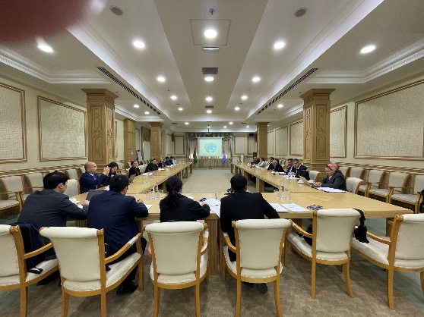 | The project also trained about 20 members of the BDST on apprenticeship programme for persons with disabilities. Also in October, 2023, Chinese experts conducted training of management staff of 3 Training and Production Enterprises BDST on the issues of creating an inclusive work environment for people with disabilities, where about 20 members participated.  In the South-South Forum, Chinese experts informed more than 61 people, including BDST members, on employment options for people with disabilities in the example of Chinese experience.

Project Output 2:

Refurbishment and re-equipment of all 3 Training and Production Enterprises of the BDST were completed in 2023. Number of new jobs created, as a result of Output 2 activities, is 75, as per report of BDST dated December 5, 2023.
The refurbishment of the printing and cardboard workshop of the TPE 1 of the BDST in Ashgabat was completed in the first half of the year and the cardboard and printing equipment procured by the project was installed and commissioned by the end of August 2023. Cardboard and printing equipment was transferred to the BDST on August 16, 2023. Opening ceremony was organized when the delegation representing China Foundation for Rural Development and China Disables Person’s Federation visited the project site between October 23-26, 2023.

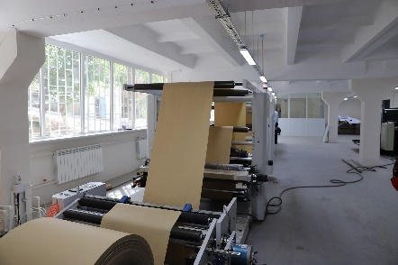 | 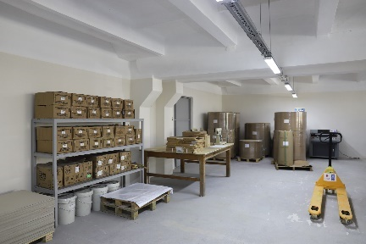 | 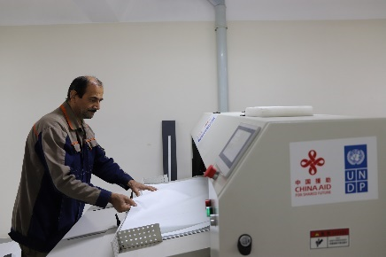

Sewing equipment were also installed, commissioned and started up in TPE of the BDST in Mary and Turkmenabat and all equipment will be transferred to BDST by the end of December 2023.

The project received the second tranche by the end of May 2023 and after that the project could start overhaul works of the sewing workshops of the BDST in the cities of Mary and Turkmenabat and complete them by the end of December 2023. As funds were available the contract of the construction company was amended twice to carry out additional works unforeseen at both sewing workshops, which created more favorable and accessible work places for people with disabilities.

Procurement and installation of equipment at 3 selected workshops of the BDST in Ashgabat, Mary and Turkmenabat:
- Printing and cardboard equipment procured for the printing workshop of TPE 1 of the BDST in Ashgabat was delivered, installed and commissioned and transferred to the BDST on August 16, 2023.
- Majority of sewing equipment procured for sewing workshops of the TPEs of the BDST in the cities of Mary and Turkmenabat was delivered, installed and commissioned and will be transferred to the BDST on by the end of December 2023 because as per the request of the BDST additional sewing equipment was procured for TPEs of the BDST in Mary and Turkmenabat. The remaining sewing equipment additionally procured will be installed and commissioned and transferred to the BDST by the end of December 2023.

Project Output 3:

Training of personnel of three selected enterprises on operation and maintenance of new equipment was conducted on the second half of 2023 after installation, start-up and commissioning of the equipment for 250 persons (147 women and 103 men): 50 persons in Ashgabat, 100 persons in Mary and 100 persons in Turkmenabat. Training curriculum was based on operational manuals for operation and maintenance of equipment.

Training of the BDST member on printing and cardboard equipment procured within the project was conducted by the supplier and a national consultant based on equipment operation documents. During several months, individualized training of the BDST staff was conducted based the equipment they were assigned to operate. Operation manuals were handed over to the BDST and some of them were translated for further usage. In addition, general group trainings were conducted between 22-26 June, 2023 for 25 (7 women and 18 men) BDST members and 19 October of 2023 for 25 (11 women and 14 men) BDST members. Each training sessions covered operation and maintenance of new printing and cardboard equipment.
Training and cardboard and printing workshop of TPE of the BDST in Ashgabat
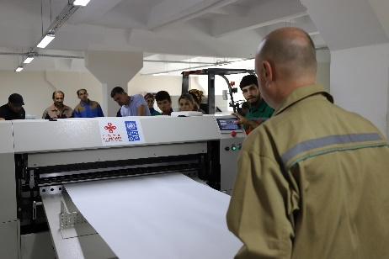 | 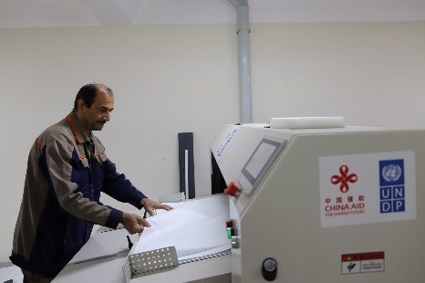 | 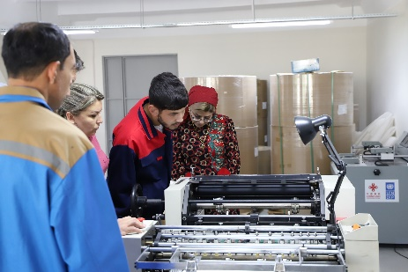

200 BDST members (129 women and 71) were trained on operation and maintenance of new sewing equipment at sewing workshop of TPE of the BDST in the city of Turkmenabat and Mary. Turkmenabat training was held between 3-7 November, 2023 for 100 persons (76 women 24 men) and Mary training was held between 8-11 November, 2023 for 100 persons (53 women and 47 men).
100 BDST members were trained on innovative approached to sewing production, relevant technical documentation and changes in the consumption rates of raw materials for clothing production, which was conducted in December 2023 (50 persons from Mary and 50 persons from Turkmenabat). On December 7-8, 2023, 50 members (2 men, 48 women) of the TPE of the BDST in Mary were trained. On December 13-14, 50 members (5 men and 45 women) of the TPE of the BDST in Turkmenabat were trained. The specialized training materials were developed for personnel of sewing workshops to be used by all 10 TPE of the BDST.
Training at sewing workshops of the TPEs of the BDST in Ashgabat and Mary
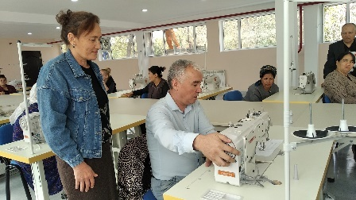 | 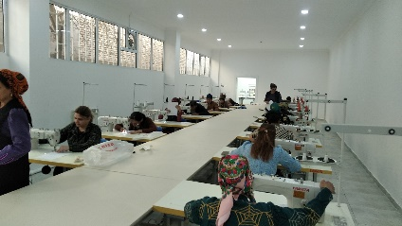 | 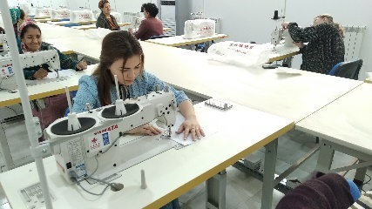
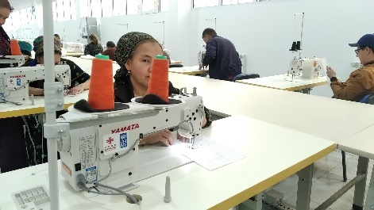 | 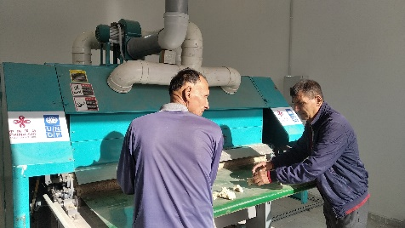 | 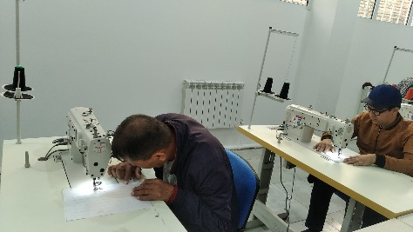

Total, the project trained 350 BDST members (110 men and 240 women). The specialized training materials were developed for personnel of sewing workshops to be used by all 10 TPE of the BDST.

In 2023, the project continued to establish and maintain a dialogue with all relevant national stakeholders on the topic of promoting education and employment opportunities for people with disabilities in the open labor market as part of round tables (15 September, October, 2023) and informal communications. As a result, two sets of documents were developed to promote vocational education and employment for persons with disabilities. The documents were shared with Parlaiment of Turkmenistan, Ministry of Labour and Social Protection of Population, Ministry of Health, Ministry of Textile Industry, and other national partners. In addition, Strategy for Developing the Capacity of the BDST an Plans and Business Strategies for Marketing Activities for three TPE of BDST completed in 2021 started to be actively used by BDST in 2023. Moreover, in 2023, the Manual on Mentoring in the Workplace for the Visually and Hearing-Impaired People of the Training and Production Enterprises (TPE) of the Society of the Blind and Deaf of Turkmenistan (BDST) was developed with support of Chinese experts and shared among 10 TPE of the BDST.

South-South Forum with participation of key national partners (ministries, agencies, TVET, higher education institutions, academia, private and public sector) BDST managers, Chinese experts from China Foundation for Rural Development and China Disables Person’s Federation, representatives of the Chinese Embassy in Turkmenistan and UNDP in Turkmenistan (total 61 participants), was conducted to raise awareness on social model of disability and inclusive approaches to vocational education and employment of people with disabilities.

Note: The United Nations Assistant Secretary-General, United Nations Development Programme Assistant Administrator and UNDP Regional Director for Europe and the CIS, Ms. Ivana Živković paid a visit to the No 1 cardboard and printing workshop of the Blind and Deaf Society of Turkmenistan (BDST) in Ashgabat on December 11, 2023.

3. Project Risks and Issues

The project Risk Log is maintained throughout the project implementation to capture potential risks to the project and associated measures to mitigate risk. The Project Manager shall maintain and update the Risk Log and ensure that risks are identified, communicated and managed effectively.

A number of potential risks are listed below.

Description of risk | Type and category | Risk management actions | Current situation
Lack of BDST operational capacity and resources to effectively respond to the fast changing business environment, obsolete training facilities and production equipment | Operational | Assessment of existing capacity and development of an institutional development strategy for BDST and new business strategy for its social enterprises | Completed  Assessment of the BDST existing capacity was provided, institutional development strategy and business strategies for the BDST three social enterprises were developed and shared with the BDST senior management for further use and guidance.
Limited local market capacity/limited number of international bidders/restricted cargo shipments across borders due to COVID-19 pandemic | Operational | Tenders for procurement of equipment and civil works were completed with some delay for objective reasons. Delivery of equipment and completion of civil works for all BDST social enterprise is expected to be completed by the end of December 2023. A project extension was requested to enable the project to complete the remaining project activities relating to operationalization of new equipment and implementation of training of staff to operate new equipment | Completed  Project no-cost extension was requested and approved in March 2023. Donor extension is December 14, while in UNDP system operational closure will be done by December 31, 2023 when all Pos are closed.
International travel restrictions because of COVID-19 pandemic | Operational | Shift activities involving international experts to online mode as much as possible. | Completed  International experts have effectively provided online and distance support to BDST capacity building activities. Further support will be provided by the international experts in a similar mode with the same quality for the remaining project activities.
Delays in inception of Project (setting a structure, recruitment of staff and experts/ consultants) | Project management and implementation | Identify the direction of the approval process (steps, deadlines, agencies, required documents);  Organize informational meetings/ round tables with key government officials (MFA, Ministry of Labour and Social Protection of the Population, Education, etc.); Review/evaluate the detailed work plan and set priorities; Develop criteria for hiring staff and experts (based on the project work plan) and conduct pre-selection (use human resources from previous projects and initiatives). | Completed
Change/rotation of employees in organisations concerned | Political and diplomatic | Enlist support from organisations (at the management level, building the capacity of a large group – the national advisory group and beyond, communication meetings/materials for all employees. | Completed  Two round tables marking International Day of Persons with Disability were conducted, discussing challenges facing PWDs in Turkmenistan and ways to address them.
Resistance to work together from organisations of people with disabilities, vocational training institutions, business and the public sector | Political and diplomatic | Organise a series of communication meetings, workshops, and round tables on general issues: access to quality vocational education and employment, to demonstrate positive lessons and benefits | Completed  The project contracted two national experts and held a series of workshops on education and employment of PWDs
Low adaptability of targeted people with disabilities to new conditions | Social | Actively involve targeted people with disabilities in the project implementation; tailored training activities for smoother adaptation of target groups. | Completed  Disability equality training was conducted. Manual on apprenticeship of newly hired blind and deaf people was developed. Trainings to operate new equipment were conducted.

4. Lessons learned and follow-up steps (if applicable)

- Major procurement activities such as procurement of equipment and civil works through international tenders need to be planned for and implemented at the outset of the project to have sufficient time for their completion given the traditional limited capacity of the local market and limited number of international bidders willing to bid for complex procurement cases.
- The project worked on three project sites and there was a desperate need for more project staff. At the design stage of the project, it should have been considered to have one dedicated project assistant and one project specialist.
- It was important for the project to slightly re-focus activities of Output 3 to achieve a long-term result in terms of transforming the BDST social enterprises into a sustainable model of vocational training for people with disabilities. This flexible practice should be applied to other similar projects because not all local conditions can be predicted at the design stage of the project.
- By the end of 2022, the project completed the recruitment process for two additional construction engineers, who could only be contracted in 2023 due to funding delay. They provided support to monitoring of overhaul works in two project sites, which was not considered at the design stage and therefore was endorsed by the donor. If the project involves reconstruction works and procurement of specialized equipment, at the design stage of the project it should be considered hiring an international expert and a national expert for assessment, providing support to tender documentation and during implementation provide consultation to a local expert as local market might not have enough specialists willing to work for small renumeration.
- Keeping responsible the providers to conduct training on operation and maintenance of new specialized equipment was a good practice, which can be used by other projects. The companies who delivered, installed and commissioned new equipment also held training for BDST members with support of a national consultant on printing and sewing equipment.
- Developing “Recommendations on promoting vocational education for persons with disabilities” and “Recommendation on promoting employment for persons with disabilities” was successful and the documents were shared with key national partners, including the Parliament of Turkmenistan and UNCT. The documents provide concrete suggestions that government and UNCT can join efforts to implement beyond the lifetime of the project and contribute to the sustainability of project achievements.
- The needs of beneficiaries should be regularly monitored, and project activities should be revisited. For example, the capacity of the BDST was increased with many knowledge products, including “Manual on Mentoring in the Workplace for the Visually and Hearing-Impaired People of the Training and Production Enterprises (TPE) of the Society of the Blind and Deaf of Turkmenistan (BDST)” was developed in 2023 with support of Chinese experts and shared among 10 TPE of the BDST.
- This type of projects could be designed as GEN2 project to empower women, because in most of the trainings women participated actively and they increased their opportunities for employment and increase their income.

Gender Equality and Women’s Empowerment

After activities of the project were completed BDST employees increased up to 582, of which 320 women and 262 men. The number of employed persons with disabilities is 415, of which 225 women and 190 men. The project strengthened capacity of BDST by training its 350 members (240 women and 110 men). Women increased their opportunities for employment and to increase their income.

5.Transfer of Assets or other related matter
Please state on any past or future transfer of assets made within the project cycle (Attach list of equipment, cooperation frameworks with beneficiaries, etc.)
- Transfer of Assets – printing equipment - completed and attached.
- Transfer of Assets – sewing equipment (Mary, Turkmenabat) – completed and attached.
- Transfer of Assets – project equipment – to be sent.
- Handover of Works (overhaul works at 3 TPEs of the BDST) - sent to the BDST

6. Financial management (AAA report from BI dated January 24, 2024)

Budget item | Total approved in 2023 (in USD) | Expenses (as per AAA report dated 24/12/2023) | Budget utilization in % to planned
Component 1 | 0 | 0 | 0
Component 2 | 1,182,177.35 | 1,119,738.66
Component 3 | 74,982.26 | 52,132.83
Total delivery in 2022 | 1,257,159,61 | 1,171,871.49
In % to total project budget

Note: Upcoming expenses: project staff cost ($2,800), GMS.

Prepared by:______________________Project Manager

Date: 29.01.2024

Approved by:____________________ Programme Specialist

Date: 29.01.2024

